**Pathway and Attribution Exercise**

**Background**

Unbranded Apparel Company’s display media efforts for May 2016 were focused mainly on Remarketing, Retention and Prospecting.

The Remarketing program targets recent site visitors (those who have visited their site in the last 7 days) regardless of prior purchase history. Ads are dynamically created depending on actions taken during their visit (e.g. categories viewed, products added to cart or purchased, etc).

The Retention program targets existing customers who have made at least one purchase in the last 12 months. Ads are created depending on the segment(s) they belong to in their CRM database.

The Prospecting program targets new potential customers with no known purchase in their CRM database. The MediaMath platform provides numerous 3rd party prospecting sources. Ads displayed are typically based on the context of the site being served on (e.g. serve a maternity ad to a prospect browsing on thebump.com).

There are also other programs, such as reactivation and miscellaneous one-off campaigns. Those should be ignored for this exercise.

**Measurement Methodology**

The main performance indicator measured for this client is Incremental ROAS.

In order to measure and take credit only for incremental orders and incremental revenue generated by these efforts, a small holdout group is served a public service announcement (PSA) instead of Unbranded’s ads to represent a control. Results for the control can be compared against the test group to determine what percentage of those sales were truly driven by the program, and wouldn’t have happened if they hadn’t seen the ad.

Incremental ROAS is calculated by first calculating Total ROAS, then calculating the Incremental Rate and then multiplying both of those to yield Incremental ROAS. To calculate the incremental rate, you first have to normalize, or scale up the control to match the test’s size based on the ratio of uniques messaged in the test versus the control. Please assume that for every unique user messaged in the control group, 18 unique users are messaged in the test group.

The below lays out steps necessary to measure Incremental ROAS:

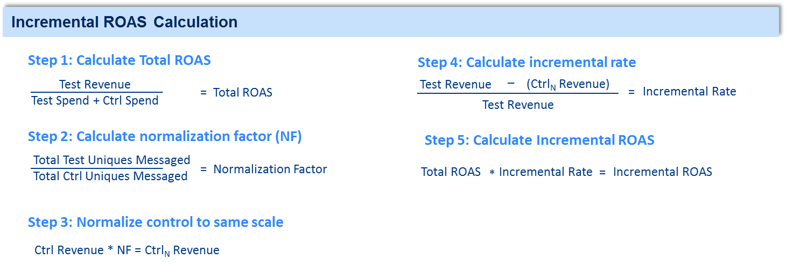

**Available Data**

You have been provided a pathway file for the month of May 2015 that presents each unique path that ultimately resulted in at least one conversion based on the type of ads they were served. The types of ads are categorized as follows:

* **E1w** Remarketing on non-FBX sites
* **E1f** Remarketing on FBX
* **E2w** Retention on non-FBX sites
* **E2f** Retention on FBX
* **A3w** Reactivation on non-FBX sites
* **A3f** Reactivation on FBX
* **A4w** Prospecting on non-FBX sites
* **A4f** Prospecting on FBX
* **NNf** Other campaigns on non-FBX sites
* **NNf** Other campaigns on FBX

A particular path is represented using those codes, separated by an arrow (>). For example, if a user was shown a Prospecting ad on CNN.com, then visited the brand’s website, then was served a remarketing ad on Facebook.com, a remarketing ad on ebay.com, and then came back to the site to place an order, the path would be represented as A4w > E1f > E1w.

The file includes one line per unique path, and includes the number of conversions, sales and average order value (AOV) for each path.

Each line also includes the impressions per unique user (frequency) by type of ad. For example, the below line item means that this path was followed by 2,217 unique users who were first served, on average, 3.33 A4w impressions (Prospecting on non-FBX sites) and were then served, on average, 40.83 E1w impressions (Remarketing on non-FBX sites). Therefore, 97,918 total impressions were served to the users who followed this path. 

Finally, most paths are repeated for those in the test group and those in the control group. In other words, the spreadsheet will have two lines for the *A4w > E1f > E1w* path; one for the test group, labeled with a T under the “T/C” field and another for the control group, labeled with a C. There will be cases where some particular paths were not replicated by the control… that’s ok.

**Attribution**

In order to associate orders to the display channel and to a particular program, the standard methodology is based on a “last touch” basis, which means that the last impression served before a conversion happens takes credit for 100% of the sale, as long as the impression takes place at least 7 days prior to the conversion. This methodology has its challenges since prospecting tends to serve impressions in the beginning of the conversion path (opener) while remarketing tends to serve towards the end of the conversion path (closer).

**Project**

1. Please calculate the following metrics for Remarketing on non-FBX sites, Remarketing on FBX, Retention, and Prospecting using the current last-touch attribution methodology:

* Total ROAS
* Incremental rate
* Incremental ROAS

1. Afterwards, re-run the analysis using a first-touch attribution model, meaning that the first impression in the path receives credit for the conversion
2. Prepare a deck that:
   * Summarizes the above results
   * Tells a story and provides insights on the different methodologies analyzed and a recommendation to the client on next steps. Things like…
     + What changed?
     + Which methodology would you recommend for some or all the programs?
     + Would you suggest an entirely different methodology?
   * Provides a perspective on the top conversion paths, and any insights on performance for those paths.
3. Please send back your results and the spreadsheet used to calculate your answers.

**Assumptions**

|  |  |  |  |
| --- | --- | --- | --- |
|  | Impressions | CPM | Normalization Factor |
| Remarketing on non-FBX | 8,657,435 | $4.67 | 18 |
| Remarketing on FBX | 17,898,738 | $1.25 | 18 |
| Retention | 2,598,798 | $5.54 | 18 |
| Prospecting | 50,879,557 | $2.34 | 18 |

*Note: All assumptions presented in the above table should be used instead of calculating through the data set, since it only includes impressions and paths that led to a conversion. All impressions that didn’t lead to a conversion are not included in the data set, hence why these assumptions are provided instead.*